Supporting information 3
Exploratory statistics addressing read depth per country and MOTU rarefaction.

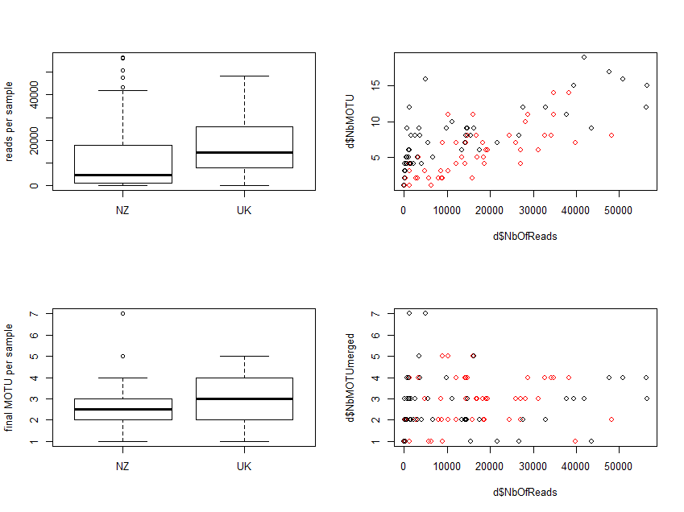

Fig. Suppl. Info 3.1 Graphs on the left show no imbalance between countries, graphs on the right show some level of rarefaction for the number of MOTUs (top right), but this disappears when considering the merging of MOTUs that could be identified to the species level (bottom right), i.e. those displayed in Figure 3 of the manuscript. In both cases, there is no effect of the country of origin (black dots are NZ, red dots are UK).

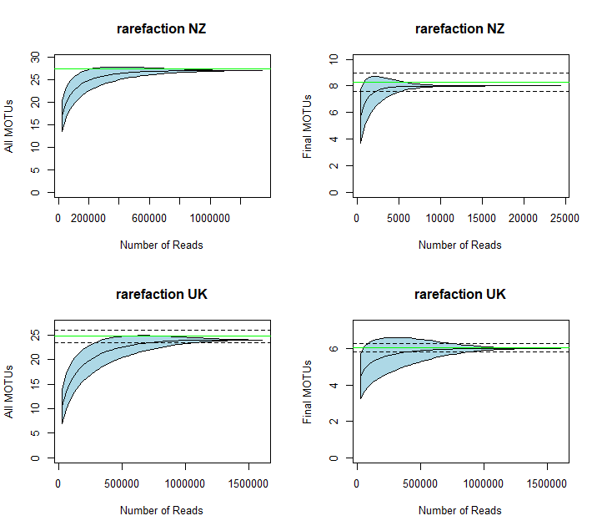

Fig. Suppl. Info 3.2 MOTU accumulation (rarefaction) curves of the number of MOTUs in NZ and the UK in relation to the number of reads. Libraries that had low number of sequences (less than 500) were removed prior to this analysis. The green horizontal lines correspond to the estimated number of MOTUs according to a bootstrap analysis, flanked by their confidence interval (dashed black lines).
When all conserved MOTUs are considered (graphs on the left), the bootstrap analysis indicates that our study discovered 98.5% of all MOTUs likely to be present in NZ and 97.1% of all MOTUs likely to be present in the UK. When only considering the final MOTUs - i.e. those displayed in Figure 3 of the manuscript -(graphs on the right), the bootstrap analysis indicates that our study discovered 96.7% of all MOTUs likely to be present in NZ and 99.1% of all MOTUs likely to be present in the UK.

