Number of specimens per sample as a function of the number of sequences per sample
Usually, metabarcoding provides species presence/absence data only, since the bias induced by different biomass of taxa and/or specimens of different size classes inhibits the inference of species abundancies (Elbrecht & Leese 2015). However, since we only used chironomid specimens (same size class) and pooled the library according to the number of specimens per sample, we could show that our read abundance highly correlates with specimen abundance (Figure Appendix 2). Thus, we could use the read abundancies as surrogates for relative species abundancies, since potential primer bias should be similar distributed across samples (Elbrecht et al. 2017). This enabled us to apply measures such as the Saprobic Index (see main text) on the detected chironomid community, making the metabarcoding approach even more superior compared to classical morphological assessments.
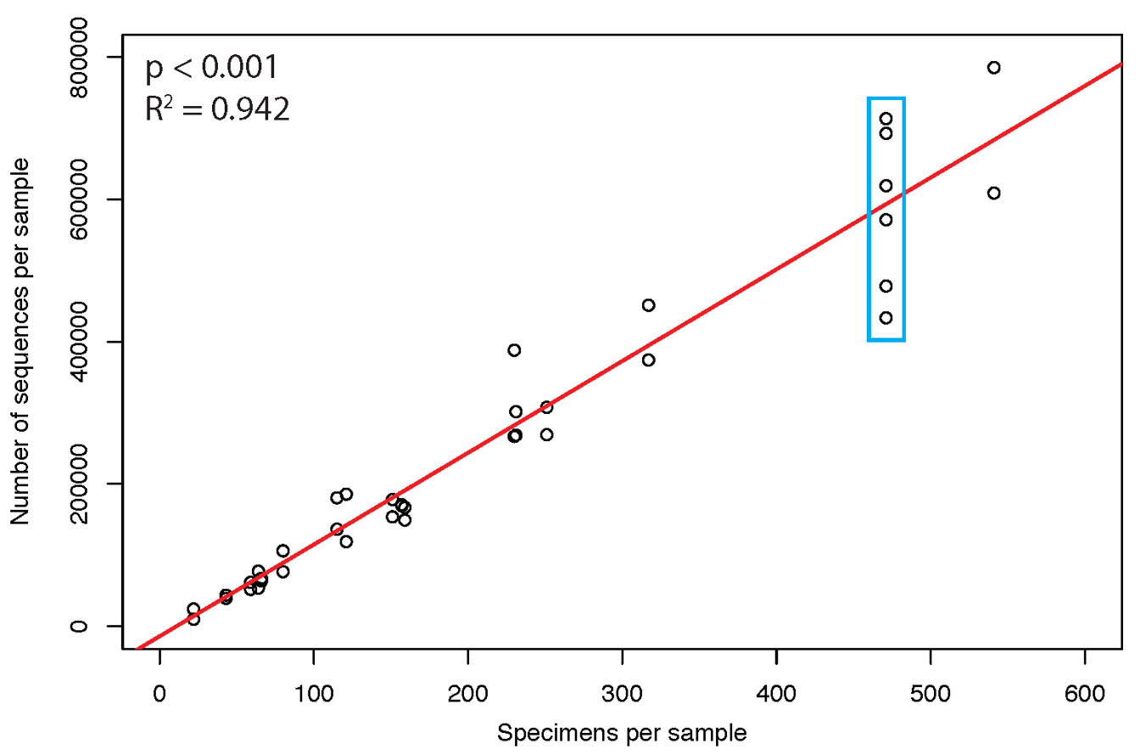
Figure Suppl. file 2: Number of specimens per sample as a function of the number of sequences per sample. The red line is the trend line for the correlation fitting the data (R2 = 94.2%) and is highly significant (p < 0.001). The technical replicates scatter slightly, indicating no strong bias based on different primer tags and combinations. The blue box indicates the control samples 04CL with six technical replicates.

